Caroline Davis

Mrs. Crawford

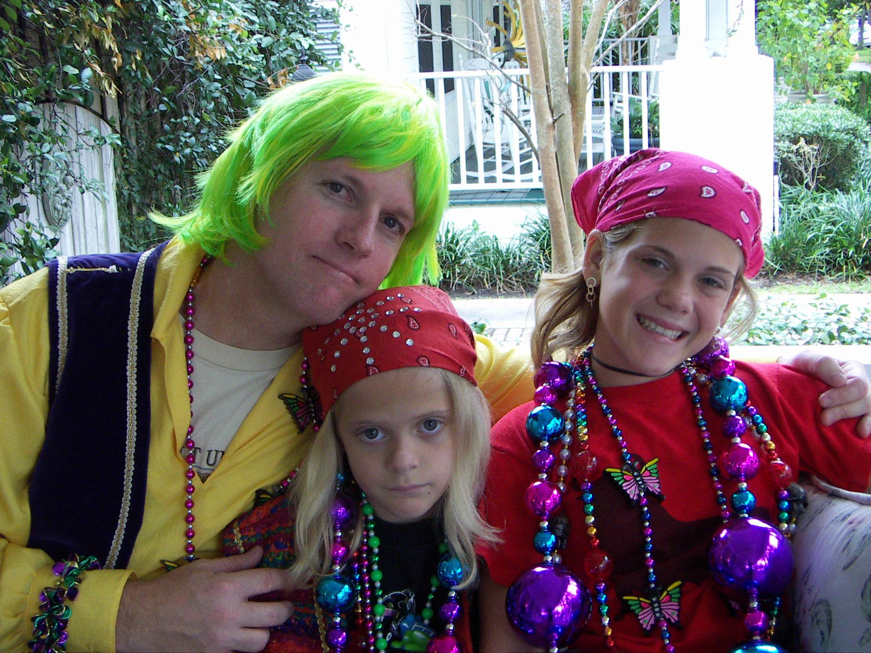

Gasparilla- an annual tradition for families living in Hyde Park, just blocks away from the fabled Bayshore Boulevard, where pirates raid the street and throw out booty to spectators. In middle division, I would load up friends in my wagon and pull them to our destination- the tent reserved specifically for children of the pirates. Dragging my loaded wagon through crowded streets, I would nimbly dodge the drunken masses, oblivious to their inebriated state, and head to the three hour spectacle that was Gasparilla. By the end of the parade, I would feel like an African tribal woman- beads piled so high up my neck I couldn’t look left or right. I was protected in my tent, ignorant of the crazy antics going elsewhere in the bleachers.

Then came high school. I was too cool to go to the children’s tent so I stopped going to the parade altogether. I would wander the streets and observe- an enraged college guy being tasered by the cops, a scantily-clad lady passed out in the grass of a poor neighbor’s front lawn, lines reaching down the block for the few port-a-potties available to the public. Very interesting visuals rarely seen expect perhaps at Mardi Gras. Sure, Gasparilla was fun…but then I had a realization this year. *My sister is a freshman*. Oh goodness, would she be doing the same thing I did and just go wander the streets instead of attending the parade? I must say, I’ve definitely become the overprotective mother this year to my younger sister. Maybe it’s because my older sister was such a terrible influence on me. Maybe it’s because I want her to not have to deal with the older guys, the mean girls, the parties, the alcohol. So what are we doing this year for Gasparilla? Cody and I are going to a math club competition.

Last weekend I went to the kids’ parade with some of my drama friends. We pushed through throngs of people to get closer to the wicket fence separating us from the pirates, threw our greedy hands skyward, and shouted for beads. Pretty far back from the parade, we didn’t have many beads coming our way. Each bead caught became a success story as we beat out at the cute little kids standing in front of us for the precious treasure. Our adrenaline flowed as we employed hand-eye coordination to snatch the flying beads out of our opponents’ grasp. As the beads slowly accumulated around my neck, I grew more eager and pushed to the front. Perhaps too eager, as I elbowed past little kids and stepped in front of a little black boy perched on his mother’s shoulders. Whoops, looks like parades bring out the worst in all of us.

It’s funny to see the effort people put in for those fake plastic beads that could easily be bought any other time of the year for less than a dollar. You are so excited to catch them, then you go home and leave them in a pile on your bedroom floor. They serve no purpose. They are just exciting to receive at that moment in time.

I hadn’t felt this type of greedy exhilaration since I had last gone to Gasparilla…eons ago…in middle division. One time, I even had the opportunity to switch roles-I got to be the pirate! My dad, little sister, and I donned on our piratey-est clothes and swaggered down to our float. Oh, the feeling of power. Everyone screaming out, looking straight at me, waving frantically. The entire world wanted my beads; I controlled their happiness. Sometimes I would throw them out quickly, other times I would dawdle, slowly untangling them from one another, wasting time as the float moved on. After all, you can’t throw all your beads out at once! An experienced parade veteran knows that. I had strategy. I didn’t throw to those loud annoying girls right at the front. Oh no, I found the ones farther back, without beads, or the sad girl getting overlooked. You had to be vigilant- some girls were sneaky, hiding their beads and pretending not to have any. Heck, I mastered that strategy by sixth grade. I would stand there, forlorn, sad face activated, and wait. The walking pirates would spot the poor, little Davis girl and give her their nicest beads. Fools. As soon as they walked off, happy that they cheered me up, I would quickly remove the fancy bead they had placed ever so gently around my neck and stuff in my already filled bag hidden covertly beneath my seat.

Methinks I might have outgrown my previous cuteness, which was so helpful during those parades. I didn’t have pirates making an effort to adorn me with beads at last weekend’s kids’ parade. In fact, I received glares! Not cute “ooh’s” and “ah’s” like the little babies in their eye patches, but looks that easily read “what are you doing here at the KIDS parade?” Oh, I’m sorry, judgmental older parents, would you like me to attend the rambunctious dangerous parade that is Gasparilla? How ‘bout I take your kid in a few years? Would you like that? No? Hypocrites.

I’m stuck at an awkward age, it would seem. I’m no longer cute. I can’t be a kid at the kids’ parade…but I’m definitely not a legal adult at Gasparilla. I don’t like feeling helpless- I like that sense of power. So I’ll avoid the whole issue. I’ll do math problems.