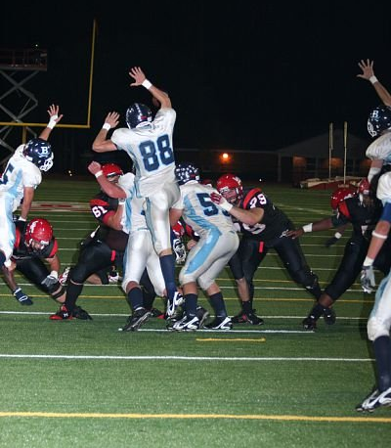Mark Timmel

Mrs. Crawford

English 12, Block A

October 1 2009

Everything You Got

This photo isn’t anything special. It isn’t the game saving play. We didn’t block the field goal. I can’t even remember if we won the game. We’ve done this probably three times a game every game for the past four years. Rounding it out I’ve done this about a hundred times. Every single time I have tried with no avail. Why is this one particular time significant? It isn’t. You are probably asking yourself “why in the world did he ever pick this?” The reason is that even though this single play is not in any way important to me, what it represents means the world to me.

To start, I am number 35 in the picture. I’m the guy to the left jumping and about to be flipped over the guard’s shoulder. I could lie and say that I’m number 88 jumping over everyone with ease, but the truth is that is Keith Bexley. Keith represents everything that I am trying to portray through this picture.

Field goal block is the single-most best play during the entire game. In all other situations there is some job a player must do; whether it be finding the hole that the guy offense runs through, taking on a block and turning the play in, or covering a man so he doesn’t get the ball. Not on field goal block. During this play, the one goal is to go full speed the second the ball moves to get in front of the holder and block the kick. It is a reckless abandonment of your body to use it as a shield for your team. Throwing your body in front of a ball that someone is kicking as hard as he can doesn’t sound very fun, but the whole purpose of the field goal block team is to go pound for pound and muscle for muscle against the other team whose only job is to make sure you don’t accomplish this feat. There is no other legal time outside of sports where someone is allowed to put pads on and hit someone else as hard as he can. This being said there are only so many chances to participate in high school football. On average there are about ten games per year. Forty games in a high school career sounds like a ton, but in reality these games fly by before you know it. This did not occur to me until the start of my senior year, when I realized that I only had ten football games left… in my entire life.

I can’t recognize number 35 in this picture at all. To me he looks like a slightly tired underclassman that felt as if it wouldn’t be the worst thing in the world not to block this kick. I see a football player just jumping up to make it look as if he were trying, yet I can still tell you exactly who number 88 is. That is Keith Bexley, a senior on the Berkeley football team, giving every ounce of his strength to try to accomplish something he only has a few chances left to do in his life. Looking at this picture I can immediately relate to Keith and understand everything that he is going through while I still find it hard to connect with that person wearing my jersey.

Now down to five games left in my life, I finally understand the gravity of the situation. To take just a single play off is to lose that play forever. That wasn’t that big of a loss for me in my sophomore year or even my junior year. The boy in the picture above doesn’t know that that missed block would make a difference in that game, nor the rest of his football career, yet it still just isn’t that important to him. Now in Keith’s position, I fear that all of my underclassmen teammates have the same lack of urgency. During my games I know I give 100% but I also know that it isn’t that way for those who still think they have time.

Looking back at this picture I have learned a few lessons. The first is never to take a play off. If you don’t do this for your own good, do it for everyone else’s. There are ten other guys on your team with you that need your help and time might be winding down for them. If I had known how badly Keith had wanted to block that field goal, then I would have put a bit more into it for him. Not only that, but on top of everything we have coaches who put their time into trying to make us the best that we can be. The second lesson learned is that you never know when it’s your last play. Earlier on this year my good friend Byrne Marston tore part of his shoulder on a tackle, ending his high school career. This is, of course, one of the worst case scenarios, but the mere thought of it scares me.

This photo isn’t anything special. It isn’t the game saving play. We didn’t block the field goal. I can’t even remember if we won the game. What I do know is that the person wearing number 35 in that picture was me, but it isn’t anymore.